



Parents and Carers Handbook
This Handbook contains information about:
Partnership with parents and carers
Admissions
Fees and charging
Attendance and punctuality
Food
Sick child
Complaints

Parents and Carers Handbook Contents

Section | Policy
1. | Partnership with Parents and Carers
2. | Admissions
3. | Fees and Charging
4. | Attendance and Punctuality
5. | Food
6. | Sick Child
7. | Complaints

This Handbook is updated every two years.

Last updated: September 2021
Updated by: Joe Knutson
Review date: September 2023

Partnership with Parents and Carers

Introduction

Staff are committed to building effective partnerships with parents and carers to support children’s well being and to enable them to thrive in the School. There is a wealth of research evidence which demonstrates that parents who are more engaged in the work of schools are more likely to understand the importance of education and to help their children to achieve their academic potential.

Aims and Objectives of Partnership

The School aims to:-

- provide a welcoming, inclusive environment where trust and respect is fostered;
- appreciate the key role of parents and carers in the education of their children and to learn from their expertise and experience;
- establish and maintain the best possible working relationships with all parents and carers, including those that are traditionally hard to reach both individually and as a group;
- demonstrate to parents and carers that we understand that their ongoing role in the education of their children is of utmost importance and offer a range of support opportunities if parents/carers feel that they would benefit;
- give parents and carers the confidence to extend their knowledge of how children learn, how they play and develop friendships and how their language develops;
- exchange information on the children’s development and progress on an ongoing basis;
- help parents to become more effective at supporting their children’s play and language development;
- consult on difficulties pertinent to the children’s education and well being with other appropriate agencies with the consent of parents/carers;
- help parents/carers to become confident advocates for their babies and young children as they move through the educational system;
- encourage parents and carers full participation in the life and workings of the School.

Qualities of the staff

The School recognises the particular qualities that staff need to build successful partnerships with parents/carers. These include:

Respect: valuing parents/carers as individuals, believing in their fundamental ability to cope and make a difference in their family lives and working within an ethos of partnership;
Empathy: showing an understanding of the challenges parents are facing in their lives and being able to see the situation from their point of view;
Genuineness: being sensitive, honest, undefensive and trustworthy;
Humility: working in the context of an equal relationship and using parents/carers strengths, views and knowledge alongside those of practitioners at every stage of the process;
Quiet enthusiasm: bringing a friendly, positive energy to the relationship and a consistent, calm, steady and warm approach;
Personal integrity: in addition to empathising with parents/carers, being able to hold alternative views and offer these when appropriate;
Expertise: the knowledge and experience that the practitioner brings to the work to complement the parents/carers existing knowledge and skills, both in building the relationship and in providing information and support.

The Parents/Carers and the Child’s introduction to School

- Parents and carers are encouraged to visit the School and/or Orchard Room before seeking a place and discussion with staff about practice is encouraged. Our Parents and Carers Handbook covers key information for families. This can be found on the school website and can be shared with families as required.
- Shortly before children start at the nursery, parents and carers are visited in the family’s home by their child’s keyworker to discuss their child’s development and interests. They also complete the “All About Me” section of their child’s Learning Journal.
- Every Parent/Carer is given a further information booklet when their child starts, which builds on the information about the workings of the School.
- An information leaflet on the importance of maintaining their family’s heritage language and sharing some of the key Makaton signs that we use is also shared during the home visit.
- Additional leaflets on supporting early Reading, Writing and Numeracy are shared with parents of children attending Nursery School at the “six weeks in” meetings.
- When children start School or the Orchard Room, they are allocated to a key person. This member of staff settles individual children and spends time with their parents/carers talking about the child’s interests, development and background in general. Staff use this information to plan appropriate learning opportunities for each child. Key persons are paired so that children (and their parents) build a close bond with a second member of the team.
- Parents and staff also confer on the duration and style of the child’s “settling in” period, recognising that each child’s needs are different.
- Parents are supported to understand their crucial role in their child’s education and that learning can happen anytime and anywhere for example through:

- being generous with praise and cuddles;
- reading things together;
- playing games and singing nursery rhymes;
- talking about what you can see in the park or on the street;
- counting things such as the stairs as you go up and down.

Ongoing Liaison with Parents

- After about half a term’s attendance parents/carers in the Nursery School are invited to a paired key worker session to give an opportunity to find out more about the philosophy and to ask any questions about practice that they might have (“six weeks in” meeting). A short information leaflet is also distributed at this time “Supporting Young Children’s Play”.

- Parents and staff exchange information on children’s progress throughout their period in School and the Orchard Room. Online Learning Journals capturing each child’s interests and achievements are available for families to look at and contribute to as they wish. Information about accessing children’s online journals is shared with families once each child starts at the nursery.

- The School and Orchard Room continue to inform parents on their approaches and other matters of educational interest through:

- Newsletters which list forthcoming events, important dates and general information;
- Displays of photographs and information on the educational significance of the workshop areas;
- Parent governor information on their role and the workings of the School is posted on the website;
- Copies of all School Policies are available to families upon request;
- Articles and Leaflets on young children’s development and other pertinent issues such as the appropriate time for a child to start Infant/Primary School are sent home to parents/carers;
- The School website containing useful information about the School’s ethos and approach.

Parents working alongside Staff in the school and in outside activities

- The staff encourage parents and carers to involve themselves in the day to day life of the School. Efforts are made to maintain a friendly welcoming atmosphere and approaches are made directly and by way of written information.
- Children of the School come from varying ethnic backgrounds. Parents are encouraged to participate in the provision of a curriculum which reflects the richness of our community’s cultural diversity.
- Staff, parents, and children regularly participate together in outings and educational visits. These provide shared experiences, offer opportunities for parents to contribute to the curriculum, and enable staff and children to benefit from parents’ knowledge and contacts in the community.

Fundraising

- Parents, staff and governors participate in fundraising activities throughout the year, for example the May Fayre. Everyone recognises the financial value of these events, in resourcing elements of the work of the School and in providing positive feelings of community cohesion, striving towards the same goals.
- Parents, staff and governors collect vouchers from local supermarkets and tokens from food packages which are exchanged for educational equipment and books.

Consultation and involvement in management

- Parents are involved directly in the management of the School through their elected representatives on the governing body.
- Questionnaires are used to gain parents/carers views on a range of key issues and on the effectiveness of the provision on an annual basis.
- Parents/carers views are used to develop priority areas for development as part of the School Development Plan.

Admissions

There are 81 (full time equivalent) places in the Nursery School for children aged 3-5 years, which are allocated during the Summer Term of the year prior to entry and then throughout the year should be places still be available. These places are allocated initially for the Autumn Term, followed by the Spring and then Summer Terms.

Parents/Carers seeking a Nursery School place can apply when their child is any age, but please be aware length of time of the application list does not give a child priority. Age of admission will depend on the number of places available.

A member of the Leadership Team will allocate places referring to the following criteria (listed in order of priority):

- children who are Looked After and/or those with an Education and Healthcare Plan;
- children with specific educational, medical and/or social needs;
- children who are currently or have recently been in receipt of a Child in Need or Child Protection plan
- children attending the Orchard Room provision;
- children who live in specific postcode areas (based on a list compiled from the Index of Multiple Deprivation);
- children with siblings currently attending the Nursery School or the Orchard Room provision;
- children with siblings who have formerly attended the Nursery School;

All 3 and 4 year old children can access Universal Free Entitlement funding of 15 hours nursery education per week during term time, starting the term after their third birthday.

Some 3 and 4 year old children can access Extended Free Entitlement funding equivalent to 30 hours nursery education per week during term time, starting the term after their third birthday. This is based on Government criteria regarding families’ work arrangements. It is the responsibility of the child’s parents/carers to find out whether they are eligible for the extended entitlement. For more information and to check your eligibility, please go to:
www.childcarechoices.gov.uk
For children in receipt of 30 hours funded entitlement, parents and carers have the option to split their funding with another setting, providing they take up 15 hours at Bognor Regis Nursery School, in one of the patterns of attendance described below. Children eligible for 15 hours funded entitlement will not have this option to split their funding with another setting.

If parents/carers working circumstances change, they should inform Nursery School immediately as this may affect their child’s free entitlement. After completing an application form, the Local Authority will check families’ eligibility for the additional hours on a termly basis.

If parents/carers become unemployed after the funding application is approved they will have a short grace period in which to find alternative employment before funding for these additional hours stops. If employment is not found, your child will move to a universal entitlement 15 hour place.

Patterns of attendance:

Universal Free Entitlement nursery education of 15 hours per week term time only can be accessed as:

- 9.00am – 12.00pm Monday to Friday
- 1.00pm - 4.00pm Monday to Friday
Extended Free Entitlement nursery education of 30 hours per week term time only can be accessed as:

- 9.00am – 12.00pm and 1.00pm - 4.00pm Monday to Friday.
Parents / Carers will collect their child for the lunch hour between 12.00pm – 1.00pm.

- 9.00am – 12.00pm and 1.00pm - 4.00pm Monday to Friday.
Parents / Carers will pay for the food and care element of the lunch hour between 12.00 – 1.00pm

Admissions for the Special Support Centre

The Special Support Centre allocates places to support children who have complex Special Educational Needs. For the criteria and admissions procedures for the Special Support Centre please refer to the Special Support Centre Policy, available on request from the nursery.

Admissions for the Day Care Provision

The Day Care provision at Bognor Regis Nursery School is a self-financing initiative which aims to provide accessible, affordable childcare to the local community.

The following places are available:

- Twenty eight full time equivalent places for children aged 0 – 3 years;
- Twenty full time equivalent places for children aged 3 – 5 years.

Day Care in the Orchard Room

Children are generally asked to attend a minimum of 3 sessions per week, to aid settling, attachment and to gain the most from their time at Nursery. However, due to parental financial restraints and availability of places this requirement may be reduced to a minimum of 2 core sessions at the discretion of the Lead Practitioner.

Session times for the fee-paying under-threes are:

- 8.00 a.m. - 1.00 p.m.
- 1.00 p.m. - 4.30 p.m.
- 1.00 p.m. - 6.00 p.m.

Session times for children accessing the 2 Year Funded spaces during term time are:

- Monday to Friday 8.45am – 11.45am
OR
- Monday to Friday 12.45pm – 3.45pm

The Leadership Team allocates places referring to the following criteria in order of priority:

- children who are Looked After and Children with an Education and Healthcare Plan;
- children with specific educational, medical and / or social needs;
- children who live in specific postcode areas (based on a list compiled from the Index of Multiple Deprivation);
- children with siblings currently attending the Nursery School or the Orchard Room provision;
- children with siblings who have formerly attended the Nursery School or Orchard Room;
- The distance from the family home ‘as the crow flies’ to the Nursery School.

Whilst every attempt will be made to ensure consistency and continuity for all children we cannot guarantee that children attending the 0-3 provision in the Orchard Room will receive a place in the Nursery School.

Daycare for Nursery School children

Subject to availability, parents and carers are able to increase their child’s Nursery education by the addition of extended services which are available all year round, there is a charge for additional sessions. The extended services of the Nursery School are closed each year for 10 closure days, 5 inset days and all statutory public holidays; you will not be charged for these days. These dates are published each year on the School website (www.brns.org).

Extra sessions offered:

Breakfast | 08.00 a.m. - 09.00 a.m.
Morning Session | 09.00 a.m. - 12.00 noon
Lunch Session | 12.00 noon - 1.00 p.m.
Afternoon session | 1.00 p.m. - 4.00 p.m.
After School Session | 4.00 p.m. - 6.00 p.m.

Requests for extra sessions must be made in writing to the Admin Team, either on the initial application form or on an Extra Session Request Form (available from the office). Every effort will be made to accommodate the needs of the parent and their child, spaces permitting, priority being given to children already on roll in the Nursery School and children of working parents. Children will only be able to access extra sessions once the contract has been signed and handed in with a deposit of two week’s fees. The Nursery School reserves the right to withdraw extra sessions from a child if payments are not being met (please read the Fees and Charging Policy for further information on this).

A waiting list is in operation for all sessions should they be full.

Casual and Emergency Admissions

We recognise that occasionally a parent may need additional, unplanned and ‘one off’ childcare sessions. In these situations, we are sometimes able to offer short term childcare for children already on roll in the setting, subject to availability. Extra sessions taken will be charged at the normal rate and an additional £3 administration fee will also be levied. Requests should be made verbally to the Admin Team in the first instance, and be followed up with the submission of an Extended Services Form. The office will confirm that an extra session has been booked by issuing an invoice to confirm payment is due. The parent will then be liable for meeting this cost even if they subsequently decide not to take up the session.

Right to Appeal

Parents and carers have the right to appeal against any admissions practice which they perceive to be contrary to the content of this policy. Complaints should be made in writing to the Headteacher (see Complaints Policy in Parents and Carers Handbook).

Fees and Charging Policy

The following Terms and Conditions are effective from 1st September 2020

Aims:
Bognor Regis Nursery School aims to provide affordable high quality childcare which is integrated with education. The Daycare element of the provision aims to provide a Charging Policy which meets the needs of parents, while ensuring that the service remains financially viable.

Childcare Fees 0–3 year olds:
Session time | Includes | Cost £
8.00am – 1.00pm | Breakfast and Lunch | 30.00
8.00am – 4.30pm | Breakfast, Lunch and Tea | 50.70
8.00am – 6.00pm | Breakfast, Lunch and Tea | 58.80
1.00pm – 4.30pm | Tea | 20.80
1.00pm – 6.00pm | Tea | 29.00
Full Week 8.00am – 6.00pm | All meals | 294.00

Childcare Fees 3-5 year olds:
Session time | Includes | Cost £
8.00am – 9.00am | Breakfast | 6.60
9.00am – 12.00pm |  | 15.30
12.00pm – 1.00pm | Lunch | 7.90
1.00pm – 4.00pm |  | 15.30
4.00pm – 6.00pm | Tea | 10.50
8.00am – 6.00pm | Breakfast, Lunch and Tea | 55.40

Daycare Agreement

The Nursery and family will sign an agreement for their child to attend a set number of sessions a week. Funded children will attend term time only. Fee paying children may attend all year round. The Orchard Room and extended services of the Nursery School are closed each year for 10 closure days, 5 inset days and all statutory public holidays; you will not be charged for these days.

To accept and secure a fee-paying place the family will be asked for a non-refundable administration fee of £15 and a deposit equivalent to two week’s fees. Once the child ceases to attend the provision, the deposit will be deducted from the final bill. Should you decide to decline your child’s place prior to them starting, the deposit is non-refundable.

Parents will be charged for sessions or meals even if a child does not attend, for example, due to illness or holidays. We require one month’s notice in writing (email will suffice) to reduce or stop your childcare sessions completely. Your deposit will be held until final settlement is made.

Fees
Fees and meal costs are payable monthly in advance. An invoice will be sent out by email on 19th of each month where possible, and is due on the first day of the next calendar month. Currently we accept payment by cash, cheque, childcare vouchers, tax free childcare, credit/debit cards and internet banking.

Late Collection Fee:
It is essential that minimum staffing ratios are maintained at all times. If a child is collected late, then staff may have to stay on beyond the end of their shift to ensure the correct ratios of staff. When this occurs, we will pass this cost on to the parents at £5.00 up to first 10 minutes and then £2.00 each subsequent five minute period.

Financial Difficulties:
It is understood that some parents/carers may experience financial difficulties and we would like to work together to minimise disruption to the child’s care and education. Parents/carers experiencing financial difficulties should discuss this with the Business Manager, as early as possible, in order to reach an arrangement regarding payment of fees.

Late Payment Charges and Procedure:
Late payments generate a lot of additional administration and so we will need to charge you £15.00 for each week that your payment is overdue. Parents can avoid this charge by ensuring that they pay nursery fees by the first day of each month

If the fees or meal costs are not paid on the first day of the month:
- parents and carers will receive a reminder via email 2-3 days after payment is due;
- if there is no response, a reminder letter will be sent asking for immediate payment of fees or to contact the Business Manager if there are financial difficulties;
- if the fees or meal costs are outstanding one week following the initial email/letter, the Business Manager will write to parents informing them that the extended services provision (paid sessions) will be withdrawn on a specified date unless payment is made in full by this date: parents/carers will be offered the opportunity to meet with the Business Manager or the Lead Practitioner to discuss and agree an arrangement for paying the outstanding amount;
- if there is no response from parents/carers by the specified date, the child’s nursery place will be terminated and any outstanding debt will be passed on to West Sussex Legal Department for recovery. This is a most undesirable outcome and we will always work with parents/carers to reach a mutually acceptable financial agreement which can be phased if necessary.

Nappies and Wipes:
Parents are requested to supply nappies and wipes for their children if they still need them. If you do not provide them you will incur an additional charge on your invoice. For current charges please speak to the School office.

Absences
If a child is absent due to illness or holidays, you will be expected to pay for these sessions. It is at the School Leaders discretion to reimburse fees or offer concessions for unexpected, prolonged absence, e.g. hospitalization. However, for absences up to 5 days all sessions much still be paid for. If your child is absent for more than ten days, you have not contacted us and we have been unable to contact you, we will assume you no longer require the place with immediate effect. You will be charged for any outstanding fees.

Policy Review
The Fee Policy will be reviewed in July each year, however we reserve the right to amend fees at any time should it be necessary. At least one month’s notice of intent to change fees will be provided to families in writing.

Attendance and Punctuality

Attendance

The school maintains records of attendance.

Parents are asked to inform the school of the reason for their child’s non-attendance on the first day of absence. The reason for absence is recorded in the school registers.

If a child is absent for a second day and no reason is sent to the school, Keyworkers will phone the parents/carers. If no contact can be made, they may use the details of further provided contacts. If the child remains absent Keyworkers will talk to the Headteacher who will look to see if any other professionals are working with the family. The Headteacher may contact the health visitor or other professionals if they feel that this would be appropriate. The Headteacher will consider whether a home visit is appropriate to ensure the safety and well-being of the child.

Punctuality

We recognise the difficulties of organising very young children to set times. Parents or carers may bring children to school during the first 15 minutes of the session.

Parents are asked to inform the school if their child is going to be late for a session, for example if they are attending a medical appointment.

Food Policy
1. Introduction
At Bognor Regis Nursery School we are seeking to promote the health and well-being of children, their families, the staff team and colleagues. We recognise that food and nutrition form an important aspect of our health and well being and contribute to our ability to learn effectively. We also recognise that food and drink play an important role in different cultures and that diversity is respected and celebrated. Food also plays an important part in our emotional and social well being. We are committed to communicating consistent messages about healthy food across the School.
2. Aims and Objectives
Our aim is for all services within the School to promote the health and well being of all members of our community: this includes food and nutrition, as part of a commitment to being a healthy school.
Objectives:
- develop a consistent approach to food and drink provision throughout the School to ensure that children learn about food and drink in line with the Early Years Foundation Stage framework;
- provide high quality meals to the children within the resources available;
- provide a relaxed social setting for children and staff to consume food and drink;
- work in partnership with parents and carers to ensure that children receive a balanced diet throughout their day

3. The Curriculum
Healthy eating is promoted through many aspects of the Early Years Foundation Stage framework. Through the curriculum we are developing the children’s understanding of the importance of food in keeping healthy.
Children are given opportunities to use a range of equipment, persist in activities, practising new and existing skills and learning from their mistakes. Staff treat mealtimes as an opportunity to promote children’s social development while enjoying food and highlighting the importance of making healthy choices.
Healthy practices such as washing hands before preparing food are encouraged. Other aspects of the curriculum are promoted through food related activities, e.g. weighing and measuring when cooking and celebrating different festivals.
4. Food and Drink Provision
- Lunch Times
School meals are provided by Chartwell’s, who are a West Sussex County Council approved food provider. The Chartwell’s menus are changed every six months. For example, please see Appendix 1.
- Breakfast and Tea
Breakfast and tea menus are devised around those that Chartwell’s provide. They are checked by the Lead Practitioner to ensure they provide a good nutritional balance across the day. For example, please see Appendix 1.
- Snack Times
Snacks are provided during the morning and afternoon session. Children are encouraged to access snacks as needed. However, the intake by individual children is monitored. On a daily basis, foods such as carrot sticks, tomatoes and cheese are offered. In addition, foods made by the children may be part of the snack, e.g. sandwiches. We welcome parents’ contributions of healthy foods to eat at snack time and give guidance as to what these may consist of.

- Drinks
Milk and water are freely available throughout the day. Squashes and fizzy drinks are not permitted.
- Group Times
In Nursery School children are offered a small piece of fruit (e.g. a quarter of an apple) at the beginning of Group Time.
- Cooking and Food Preparation Activities.
Staff endeavour to ensure a wide range of different food related activities are available when planning for the children. Children experience a range of food preparation activities and cooking skills. Ingredients may be supplemented by those from our garden to aid children’s awareness of where their food comes from. Special emphasis is given to hygiene practices such as cleaning surfaces with antibacterial spray and washing hands before and after food preparation.
- Special Dietary Needs
- Babies
For babies who are still bottle fed, parents are requested to supply bottles and formula or breast milk. The nursery staff sterilise all feeding equipment for babies up to twelve months. This takes place in the Orchard Room kitchen. Staff make up formula feeds as advised by parents, also in the Orchard Room kitchen. All milk feeds are stored in the fridge in the Orchard Room. Feeding routines already established will be discussed prior to a child starting at Nursery and wherever possible these routines will be continued.
Meals served at lunch time will be blended to a manageable consistency for younger children.
- Other Dietary Needs
Parents are asked to inform the Nursery of any dietary requirements, cultural and religious exclusions or allergies. If a child is allergic to any food, parents are required to tell the staff of any likely reaction their child may have. If children stay for the Chartwell’s lunch, the parent will be asked to fill in Chartwell’s own paperwork to detail the dietary needs. This information will be used by Chartwell’s to provide an appropriate meal. Information regarding any dietary needs is displayed for staff in every area. Children will be offered an alternative where there is a dietary requirement.
- Celebrations and Treats
During celebrations such as Birthdays, Diwali, Christmas and Easter children may be given special treats such as sharing a birthday cake that a child has brought into the Nursery, party food at Christmas. Food from other cultures may be shared during celebrations such as Chinese New Year. Throughout the year there are occasional fund raising events such as cake stalls and a Summer Fete where ice creams are sold. If food is brought in from home, parents will be requested not to bring in foods that are high risk e.g. cream, meat, raw eggs, fish, dairy, cooked rice.
5. Environment
In the Orchard Room, meals are eaten in the room. The tables are set up so that children can sit in small groups with their Key Worker where possible.
In the Nursery School, meals are eaten in the ‘Tasty Space’ room and upstairs at lunchtime, again in small groups with a member of staff. Mealtime staff eat with the children providing them with good role models and promoting social interaction. We aim to provide a relaxed atmosphere where children can chat quietly to adults and friends.
6. Other Initiatives
The School is working towards achieving ‘Healthy Schools Status’ which includes a Healthy Eating element.
The Nursery also has a growing area in the garden where fruit and vegetables are produced with the children which are used in food preparation and eaten by the children.
7. Children’s Well Being
All staff are trained in Child Protection and Safeguarding issues and report any concerns to the designated member of staff. Meal time staff will pass on any information about changes in the child’s normal eating pattern to his/her Key Worker.
8. Professional Development
If needs are identified, staff will be offered relevant training such as Food Hygiene and Basic Nutrition. Most staff who deal with any food preparation are trained or are working towards achieving the basic food hygiene certificate.
New staff working in Daycare will be asked to watch ‘Safer food, Better business’ DVD as part of their induction process.
9. Food Co-ordinator
The Lead Practitioner oversees all aspects of food in the School and is responsible for creating menus for meals taken throughout the day.
10. Monitoring and Evaluation of the Policy
The Lead Practitioner and the Physical Development Coordinator analyse monitoring evidence and inform the Leadership team on an annual basis.
Key workers assess children’s knowledge of healthy food and drink practices and record these in their ongoing records of achievement.

Observations of the children at meal times provide parents and staff with knowledge of the individual preferences. This knowledge will be used to inform the Outside Caterer and Lead Practitioner and used for future menu planning and to ensure children receive a nutritionally balanced intake throughout each day, week etc.
On going evaluations will be made of the balance of food related activities offered in the Tasty Space.
Information will be fed back to the Governors through the Head Teacher’s reports.

Sick Child

Preventing the spread of disease and infection at nursery

The School ensures that basic infection prevention and control principles are embedded in everyday practices and procedures. Such practices include good hand hygiene, wearing personal protective clothing as appropriate and following statutory guidelines when cleaning spillages or removing domestic and clinical waste. Children are encouraged to participate in healthy practices such as washing hands and covering their mouth when coughing.

The School notifies parents of vulnerable children and pregnant women of any diagnosed contagious illnesses. It also tracks any trends where appropriate and informs the local Health Authority of any outbreaks or notifiable diseases. The School is responsible for informing Early Years Ofsted as soon as possible if a child who attends the Daycare Provision has, or is suspected of having, a notifiable disease such as Norovirus.

If the child has an infectious illness, the family should seek advice from their GP on how long the child should be absent, or parents can check the exclusion period with the School.

If a child becomes ill at home

Children should not come to nursery if they have an infectious illness or are unwell.

Parents should let the nursery know if their child is absent due to illness and also the nature of the illness.

As a general rule, if a child is unwell with diarrhoea or vomiting they should be absent from nursery until they have been completely well for forty-eight hours. Further information regarding exclusion periods and infection control for infectious diseases is available in Appendix 1.

If a child becomes unwell at nursery

The health and safety of children is paramount. If a child becomes unwell at nursery and needs to go home, nursery staff will contact the parents to arrange for the child to be collected.

Staff will care for the sick child by making them as comfortable as possible in a quiet place where there will be minimal contact with other children and staff to prevent cross infection.

If unable to contact parents immediately, staff will continue to telephone at regular intervals until they have contacted the family. Parents of a sick child are expected to make arrangements for the child to be collected as soon as possible.

If a child becomes increasingly unwell and the parents cannot be contacted or have not yet arrived, staff will seek and follow medical advice according to the needs of the child.

If a child experienced a ‘life-threatening episode’ such as faints, fits or convulsions whilst in our care, we will phone for an ambulance and parents would be informed immediately.

High temperature

If a child feels hot to the touch, or otherwise presents as unwell, nursery staff may take the child’s temperature using a sanitised ear thermometer. When a child’s temperature is 37.8 degrees and over staff will telephone parents to inform them. If staff and parents feel that the child needs paracetamol but is still well enough to be in nursery, we will ask that parents come in and administer this themselves. It is, however, more likely that a raised temperature is indicating that the child is unwell and would be best looked after at home. If parents are unable to come into nursery and the child’s temperature reaches 40 degrees staff will phone for an ambulance. If the advice from the ambulance services clinicians or paramedics is to administer paracetamol to children, staff will follow this advice. Details of contact made to parents and emergency services will be recorded on proforma attached as Appendix 2. In anticipation of such an event, liquid paracetamol will be kept onsite. Parents are asked to sign the permission booklet for such emergencies before their child starts in the Orchard Room or Nursery School.

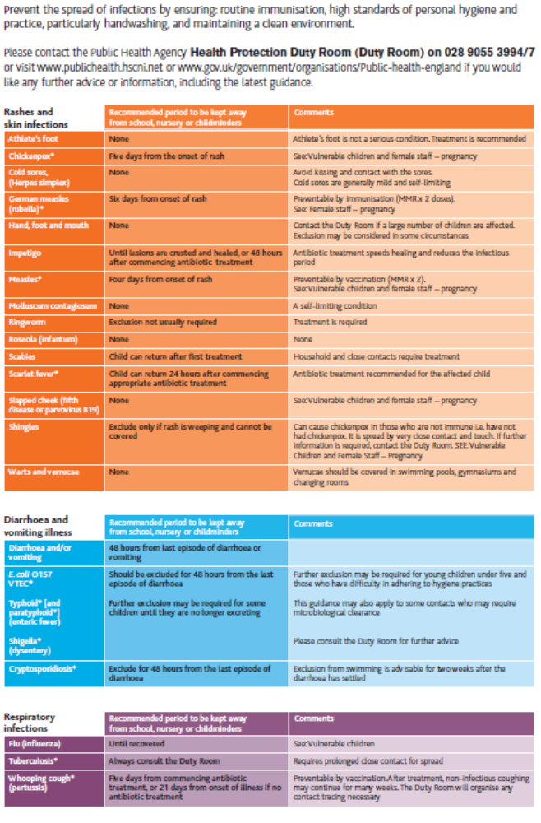


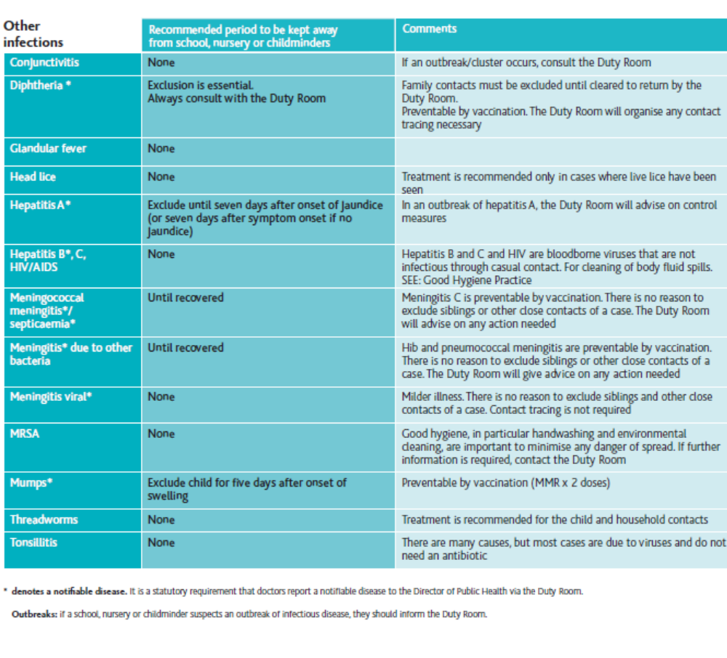

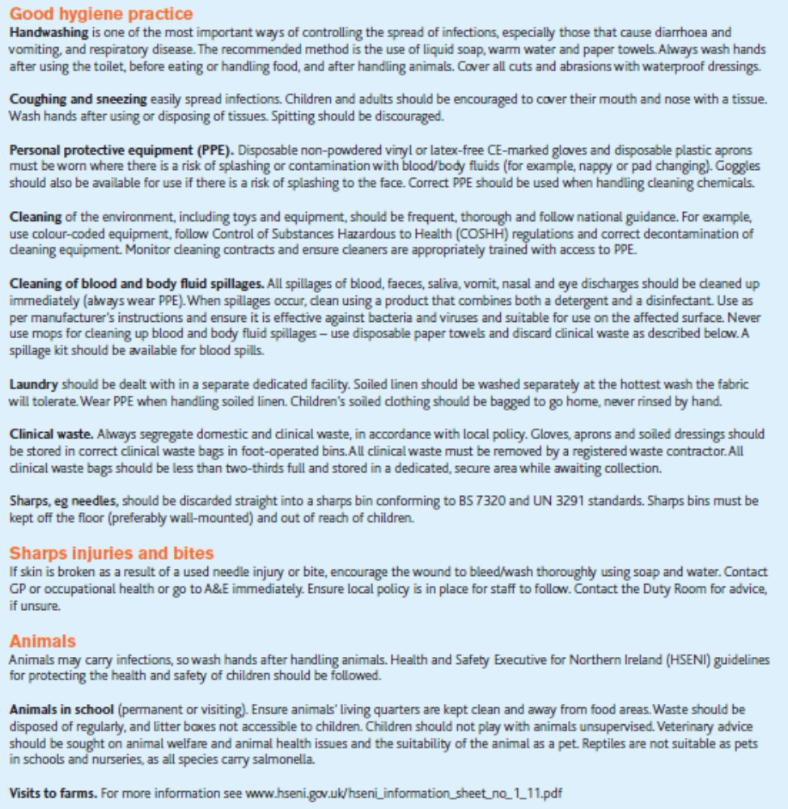

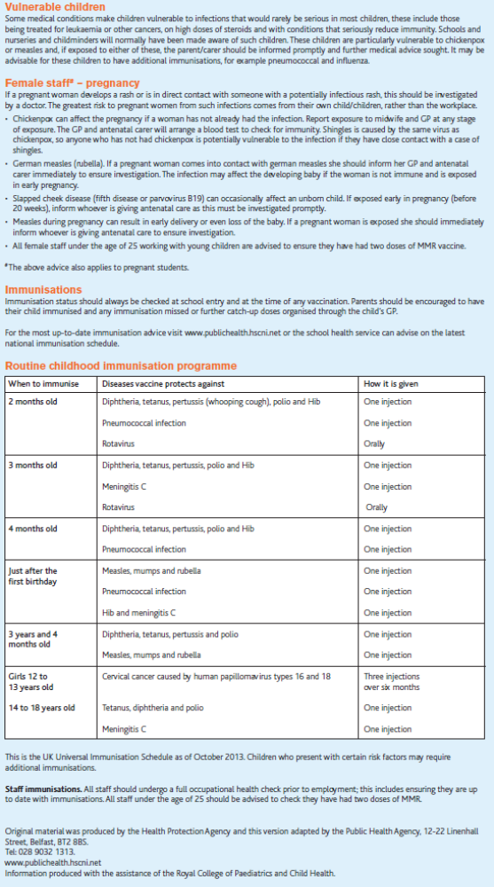

Appendix 2

Developing Emergency Situation that might result in Administering Calpol (Liquid Paracetamol)

Child’s Name:

Child’s Temperature:

Contact to parents:

Date of contact:

Time of contact:

By (Staff Name):

Parent/Carer Name:

Parents approximate time of arrival:

If unable to contact parent:

Emergency Services called at:

Child’s temperature at time of call:

Advice given by Emergency Services:

If Emergency Services advice is to administer liquid paracetamol:
Medicine Name: |  | Dosage/Instruction/Number of Spoons:
Date | Time Given | Administered By | Witnessed By
Parent/Carer Signature

Bognor Regis Nursery School

Who to go to if you have any concerns?

It is very important that both you and your child feel confident with us, and that you
access the highest quality of service as soon as you pick up the phone or step through the door of our School. If there is anything that you are unhappy about, we encourage you to share this with us so that we can work together to resolve the difficulty.

Stage 1

If you have any concerns of any kind, we ask that you first speak to your child’s Keyworker or the member of staff that is offering the service to see if the issue can be addressed informally by talking it through.

Stage 2

If parents/carers feel that they cannot do this or that the issue is more serious they should arrange to meet with Joe Knutson (Headteacher).

You can do this directly, by emailing head@brns.org or by asking the reception office for an appointment.

At this meeting we would look for solutions and agree any actions that may be necessary.

Stage 3

If you still feel that situation remains unresolved, parents/carers should make a formal Complaint, in writing, to the Chair of Governors, Susannah Conway, c/o Bognor Regis Nursery School and it will be passed to her as soon as possible.

Stage 4

If you are not satisfied with the outcome of the Stage 3 investigation, parents/carers should write to the Clerk to the Governing Body, Shelley Farrell, c/o the School Office and marked ‘Private and Confidential’ to request that their complaint is considered by a Complaints Appeal Panel.

The Chair of Governors, or if the Chair has been involved at any previous stage in the process, another nominated governor, will convene a Governing Body Complaints Appeal Panel.

Your views are important and we urge you to raise any concerns with us.
We will always listen to you and act to improve the situation where appropriate.

Complaints Policy
(Parents/Carers)

Status: Statutory, pursuant to Chapter 1 of Part 3 of the Education Act 2002, Chapter 2 of Part 10 of the Apprenticeships, Skills, Children and Learning Act 2009, and the Complaints Against Schools (England) Regulations 2010.

Purpose: This Complaints Policy applies to a complaint or complaints against a School that a child or a parent of a child has sustained injustice in consequence of an act or omission of the Governing Body of the School or an exercise of, or failure to exercise a prescribed function of the Headteacher of the School. It does not apply to a decision about admissions to the School, or a matter in respect of which the parent has or had a prescribed right of appeal. An act is to be treated as an act of the Governing Body of the School where a person acts on behalf of the Governing Body, or is a person to whom the Governing Body has delegated any functions. An act is also to be treated as an act of the Governing Body if the Governing Body exercises a function by arrangement with another person, and the act is done by or on behalf of the other person carrying out the arrangement. The School and Governing Body aim to deal with all complaints openly, fairly, promptly and without prejudice.

Relationship with other policies: This Complaints Policy should be read in conjunction with the policy on Complaints (General) and all other School policies in force at the relevant time.

Who was consulted? All staff and parents, and the Local Authority were consulted before adopting this policy.

Roles and responsibilities: The relevant Key Worker should attempt to resolve all complaints by parents involving the education and well being of children in the School. If the relevant Key Worker is unable to resolve the complaint, it will pass to the Headteacher. If the complaint is about a member of School staff, this should be dealt with by the Headteacher. If the Headteacher is unable to resolve the matter, or the complaint is about the Headteacher, the complaint will pass to the Chair of Governors and the final stage in the process is for the Governing Body to investigate the complaint. Please see the separate procedure for dealing with complaints available from the School.

(General: Other than Parents/Carers)

Status: Statutory, pursuant to Chapter 1 of Part 3 of the Education Act 2002, Chapter 2 of Part 10 of the Apprenticeships, Skills, Children and Learning Act 2009, and the Complaints Against Schools (England) Regulations 2010.

Purpose: This Complaints Policy applies to any complaint relating to the School or the provision of facilities or services not covered under the Complaints Policy (Parents/Carers), or any other prescribed right of appeal. The School and Governors aim to deal with all complaints openly, fairly, promptly and without prejudice.

Relationship with other policies: This Complaints Policy should be read in conjunction with the policy on Complaints (Parents/Carers) and all other School policies in force at the relevant time.

Who was consulted? All staff, pupils and parents, and the Local Authority were consulted before adopting this policy.

Roles and responsibilities: The School Business Manager should deal with all complaints not covered by the Complaints Policy (Parents/Carers). If the School Business Manager is unable to resolve the complaint, it will pass to the Headteacher. If the Headteacher is unable to resolve the complaint it will pass to the Chair of Governors. The final stage in the process is for the Governing Body to investigate the complaint. The Chair of

Governors and/or the Governing Body will deal with complaints about the Headteacher. Please see the separate procedure for dealing with complaints available from the School.
Complaints Procedure
Stage 1 [Informal] – Complaint heard by staff member
Where a complaint is raised by a parent/carer the Key Worker will receive the complaint. In the case of a complaint from any other individual in respect of any community facility or service provided by the School, the School Business Manager will receive the complaint.

  - In the first instance the complainant should make an appointment to discuss their concern with the appropriate member of staff.
  - The complainant can bring a companion with them to any proposed meeting.
  - As good practice a written record will be made of the meeting. All parties will have access to the record (Informal Complaints form - see Appendix 1).
  - The person facilitating the meeting will ensure all parties are clear about any actions that have been agreed as a result.
  - This stage will be dealt with as speedily as possible and concluded in writing, as appropriate.
  - If no satisfactory resolution is reached the complainant can refer the complaint to the Headteacher, Joe Knutson (if he was not the member of staff the concern was initially discussed with at point 1.1).
If the member of staff directly involved feels too compromised to deal with a complaint, the Headteacher may consider referring the complaint to another member of staff. The member of staff may be more senior but this is not a requirement. The ability to consider the complaint objectively and impartially is crucial.
  - Where the first approach is made to a governor, the next step would be to refer the complainant to the appropriate person and advise them about the procedure. It would be useful if governors did not act unilaterally on an individual complaint outside the formal procedure or be involved at the early stages in case they are needed to sit on a panel at a later stage of the procedure.

Stage 2 [Formal] – Complaint heard by Headteacher or by Chair of Governors if the complaint is about the Headteacher.

  - A Formal Complaint form will be given to the complainant to complete and return to the School office marked Private and Confidential to the Headteacher or Chair of Governors (see Appendix 2). The Headteacher, will gain clarity over the complaint and gain any supplementary information which may lead to resolution at this stage.
  - If resolution not found, the Headteacher will meet with the complainant and/or subject of the complaint, if appropriate.
  - The Headteacher will meet, as appropriate, with any witnesses and take statements from those involved.
  - Notes will be kept of all meetings, conversations and of the receipt of any documentation.
  - After establishing all the relevant facts, a written response will be recorded and sent to the complainant. The Headteacher may meet with the complainant to discuss their findings as he decides is appropriate.
  - The written record and response will include a full explanation of the decision reached and the reasons for this. If any action is to be taken at the School, this will also be identified.
  - The Stage 2 processes will take place within a reasonable time, and usual practice is that this may take up to 10 school days, however, every complaint is different and this may not always be possible. The Headteacher will keep the complainant informed in writing of the on-going time scale.
  - If the complainant is not satisfied with the outcome of the Stage 2 investigation, or the complaint is about the Headteacher, the complainant should write to the Chair of Governors to request that their complaint is considered further.

Stage 3 [Formal] - Complaint heard by the Chair of Governors or another nominated governor

  - If the complainant is not satisfied with the response of the Headteacher or the complaint is about the Headteacher, the complainant should write to the Chair of Governors, Susannah Conway, to request that their complaint is considered at Stage 3.
  - Once the complaint has been received, the Chair of Governors (or another governor nominated by the Chair of Governors) will gain clarity over the complaint and gain any supplementary information which may lead to resolution at this stage.
  - The Chair of Governors (or nominated governor) will meet with the complainant and/or subject of the complaint, if appropriate.
  - The Chair of Governors (or nominated governor) will meet, as appropriate, with any witnesses and take statements from those involved.
  - Notes will be kept of all meetings, conversations and of the receipt of any documentation.
  - After establishing all the relevant facts, a written response will be recorded and sent to the complainant. The Chair of Governors (or nominated governor) may meet with the complainant to discuss their findings as she decides is appropriate.
  - The written record and response will include a full explanation of the decision reached and the reasons for this.
  - The Stage 3 processes will take place within a reasonable time, and usual practice is that this may take up to 10 school days, however, every complaint is different and this may not always be possible. The Chair of Governors (or nominated governor) will keep the complainant informed in writing of the on-going time scale.
  - If the complainant is not satisfied with the outcome of the Stage 3 investigation the complainant should write to the Clerk to the Governing Body, Lisa Collins, c/o the School Office and marked ‘Private and Confidential’ to request that their complaint is considered by a Complaints Appeal Panel.

Stage 4 [Formal] – Complaint heard by Governing Bodies Complaints Appeal Panel

4.1 The complainant should write to the Clerk to the Governing Body, Lisa Collins, c/o the School Office and marked ‘Private and Confidential’ giving full details of the complaint and requesting the Complaints Appeal Panel consider the matter. The Clerk to the Governors should acknowledge receipt within five school days.
4.2 The Chair of Governors, or if the Chair has been involved at any previous stage in the process, another nominated governor, will convene a Governing Body Complaints Appeal Panel.
Individual complaints would not be heard by the whole Governing Body at any stage, as this could compromise the impartiality of any panel set up for a disciplinary hearing against a member of staff following a serious complaint.
4.3 In line with good practice a Clerk will be appointed to the Governing Body Complaints Appeal Panel at the start of Stage 4 to support the process and be the point of contact for the complainant. It would be good practice to notify the Headteacher of the complaint at this stage if they have not previously been involved in the process.
4.4 The Clerk to the Governing Body Complaints Appeal Panel will:
  - set a convenient date, time and venue for the complaint to be heard;
  - deal with all administration of the procedure;
  - take notes at any meetings;
  - be a single point of contact to facilitate communication between all parties;
  - draft and despatch letters as required;
  - liaise with the Local Authority and other agencies for support/advice as requested.

4.5 The Complaints Appeal Panel must be established by drawing on governors with no prior or direct involvement with the complaint. It should also aim to provide a cross section of governors. If this is not possible from its own membership the Governing Body will consider approaching and appointing governors from neighbouring maintained schools.
4.6 The Headteacher must not serve on the Complaints Appeal Panel. The Chair of Governors must not serve on the Complaints Appeal Panel if she has had any prior involvement with the complaint.
4.7 Complainants have the right to request an independent panel if they believe there is likely to be bias in the proceedings. Schools should consider the request but ultimately, the decision is made by the governors.
4.8 The Complaints Appeal Panel will be provided with any collated written material, reports, and relevant information and will consider the complaint on the basis of the written evidence available. The Complaints Appeal Panel may decide to request further clarification from the complainant and Headteacher before writing and notifying them of the arrangements for the formal panel meeting. Any additional information received by the Complaints Appeal Panel must be shared with all parties prior to the meeting.
4.9 The Panel members will decide how the meeting will be conducted and who is present. The
panel should decide whether to meet each party individually or invite all to attend at the same
time.
4.10 The Clerk will write to all relevant parties informing them of the date and time of the meeting, whether the Panel will consider written evidence only or will be inviting them to attend and give an outline of how the meeting will be conducted. The Clerk must include a copy of all relevant documents, policies or procedures that will be considered by the Panel at the meeting. Notification of the Panel meeting must be sent not less than five school days before the meeting.

All parties should acknowledge receipt of the meeting notification and all related documentation itemised in the accompanying letter.

4.11 Within reason, the Clerk will arrange a date and time for the Panel meeting that is convenient to the complainant and other relevant parties if they are attending in person.
4.12 The complainant has a right to be accompanied to the meeting by a friend/representative.

The friend/representative may:
- confer with the complainant during the meeting;
- ask questions of witnesses;
- sum up the complainants complaint if requested by them.

The friend or representative may not:
- answer questions on the complainants behalf;
- address the Panel if the complainant does not wish it;
- prevent the complainant from summarising the complaint.

4.13 Good practice requires all written evidence to be submitted prior to the meeting wherever possible so that it can be considered by all parties.
4.14 If necessary the Panel meeting will be adjourned if there is insufficient time to consider extra evidence received at the start of the meeting to enable it to be circulated and considered by all parties.
4.15 The Panel may wish to call witnesses to the meeting.
4.16 The complainant, and other parties previously involved in the complaint if invited, can expect the following process to be followed:
  - the hearing will proceed in an informal, but appropriate manner;
  - witnesses shall be present only for the part of the hearing relevant to their involvement and may not remain for the entire hearing (at the discretion of the Chair of the Panel);
  - introductions shall be made by all parties present;
    - the complainant will be invited to explain the complaint;
    - the Headteacher will be invited to explain the reasons for decisions reached up to this point;
    - if all parties are in attendance together, the complainant may then question the Headteacher;
    - if all parties are in attendance together, the Headteacher may then question the complainant;
    - the Panel may ask questions of any party at any time;
    - witnesses, subject to prior approval by the chair of the complaints appeal panel, to be called;
    - all parties to have the right to question all witnesses;
    - the complainant will be invited to sum up their complaint, and then the Headteacher will be invited to sum up the school’s position and response to the complaint.
4.17 At the conclusion of the Complaints Appeal Panel hearing the Chair of the Panel will inform the complainant and the Headteacher that the Panel will consider its decision in private and will send a written response within 10 school days. At this point all parties other than Panel Members and the clerk must vacate the room.
4.18 The Panel will consider the original written complaint, along with all subsequent evidence that has been presented both orally, and in writing. The remit of the Panel is to:

(a) dismiss the complaint in whole or in part;
(b) uphold the complaint in whole or in part;
(c) decide what, if any, action should be taken to resolve the complaint;
(d) recommend any changes, if appropriate, to the School’s processes or systems to
ensure similar complaints do not arise again the future.

The Panel will present their findings in writing.

4.19 The Clerk or Chair of the Panel will ensure the written findings outlining the Panel’s decision are sent to both the complainant and the Headteacher.
4.20 Stage 4 should be completed in 25 School days. However, this may not always be possible, especially if a complaint is complex, and where that is the case, the Clerk will ensure both parties are written to and advised of the revised target date.
4.21 There is no right of appeal against the Governing Body Complaints Appeal Panel decision. If the complainant remains dissatisfied and believes the Panel has acted unreasonably in response to the complaint, the complainant should be advised to contact The Secretary of State, Department for Education, Sanctuary Buildings, London, SW1 or in some circumstances, Ofsted if the complaint is likely to lead to a determination there is a need to inspect. Ofsted cannot seek to resolve any individual complaint.

Role of The Secretary of State, Department for Education

For The Secretary of State to become involved, he would need to be sure that:
The school has acted or is proposing to act unreasonably in the exercise of performance of its functions imposed by or under the Education Act 1996.
Or
The school has failed to discharge any duty imposed by or for the purposes of the Education Act 1996.

If the complainant believes that this is the case they should refer to the Department for Education website where guidance can be found to support the next part of the process. The relevant guidance can be found at: https://www.gov.uk/complain-about-school

The complainant may find the following useful:
- Further information can be obtained from the SCU by calling the National Helpline on 0370 000 2288 or by going online at: www.education.gov.uk/help/contactus;
- The complainant must complete a complaints form and return it online or by post to the Department for Education, School Complaints Unit, Second Floor, Piccadilly Gate, Store Street, Manchester, M1 2WD;
- Copies of relevant documentation relating to the complaint may be sent with the form;
- The DfE will inform the complainant who will be handling the case and a timescale for the process when they have received the form;
- The DfE aim to initially respond within fifteen working days but update the complainant if the timescale is longer.
If the complainant remains unhappy with the service given by the DfE in processing the complaint they would need to contact the DfE complaints department and follow the DfE complaints procedure.

Role of Ofsted

It will not investigate cases to do with individual pupils.
A complainant can complain to Ofsted about any state school if there is a problem that affects the whole school. This includes problems with the quality of education or poor management.
Ofsted have an on line form and aim to respond within 30 working days. Their initial response will tell you if Ofsted will investigate or not, and why.
https://www.gov.uk/complain-about-school

For concerns and complaints about the Orchard Room provision or Daycare for children aged 3-5 (outside the child’s core hours) please contact Ofsted on 0300 123 1231 or write to:
Applications, Regulatory and Contact (ARC) Team, Ofsted, Piccadily Gate, Store Street, Manchester. M1 2WD

Serial and Persistent Complaints
There will be occasions when, despite all stages of the School’s complaints procedure having been followed, the complainant remains dissatisfied. If the complainant tries to reopen the process by writing to the Chair of Governors, or any member of school staff, with the same complaint, the Chair of Governors may respond to them in writing that all stages of the School’s complaints procedure have been exhausted and that the matter is now closed.
Unreasonable Complainants

Bognor Regis Nursery School is committed to dealing with all complaints fairly and impartially, and to providing a high quality service to those who complain. We will not normally limit the contact complainants have with the School. However, we do not expect our staff to tolerate unacceptable behaviour and will take action to protect staff from that behaviour, including that which is abusive, offensive or threatening.

Bognor Regis Nursery School defines unreasonable complainants as ‘those who, because of the frequency or nature of their contacts with the School, hinder our consideration of their or other people’s complaints’.

A complaint may be regarded as unreasonable when the person making the complaint:-

- refuses to articulate their complaint or specify the grounds of a complaint or the outcomes sought by raising the complaint, despite offers of assistance;
- refuses to co-operate with the complaints investigation process while still wishing their complaint to be resolved;
- refuses to accept that certain issues are not within the scope of a complaints procedure;
- insists on the complaint being dealt with in ways which are incompatible with the adopted complaints procedure or with good practice;
- introduces trivial or irrelevant information which the complainant expects to be taken into account and commented on, or raises large numbers of detailed but unimportant questions, and insists they are fully answered, often immediately and to their own timescales;
- makes unjustified complaints about staff who are trying to deal with the issues, and seeks to have them replaced;
- changes the basis of the complaint as the investigation proceeds;
- repeatedly makes the same complaint (despite previous investigations or responses concluding that the complaint is groundless or has been addressed);
- refuses to accept the findings of the investigation into that complaint where the School’s complaint procedure has been fully and properly implemented and completed including referral to the Department for Education;
- seeks an unrealistic outcome;
- makes excessive demands on School time by frequent, lengthy, complicated and stressful contact with staff regarding the complaint in person, in writing, by email and by telephone while the complaint is being dealt with.

A complaint may also be considered unreasonable if the person making the complaint does so either face-to-face, by telephone or in writing or electronically:-

- maliciously;
- aggressively;
- using threats, intimidation or violence;
- using abusive, offensive or discriminatory language;
- knowing it to be false;
- using falsified information;
- publishing unacceptable information in a variety of media such as in social media websites and newspapers.

Complainants should try to limit the numbers of communications with the School while a complaint is being progressed. It is not helpful if repeated correspondence is sent (either by letter, phone, email or text) as it could delay the outcome being reached.

Whenever possible, the Headteacher or Chair of Governors will discuss any concerns with the complainant informally before applying an ‘unreasonable’ marking.

If the behaviour continues the Headteacher will write to the complainant explaining that their behaviour is unreasonable and asking them to change it. For complainants who excessively contact Bognor Regis Nursery School causing a significant level of disruption, we may specify methods of communication and limit the number of contacts in a communication plan. This will usually be reviewed after 6 months.

In response to any serious incident of aggression or violence, the concerns and actions taken will be put in writing immediately and the police informed. This may include banning an individual from Bognor Regis Nursery School.

Further guidance about how to deal with such complaints can be found on page 10 of the Best Practice Advice for School Complaints Procedures 2016
https://www.gov.uk/government/uploads/system/uploads/attachment_data/file/489056/BestPracticeAdvice_for_School_Complaints_2016.pdf

Appendix 1
Bognor Regis Nursery School

Record of Complaint

A: Source of complaint
Parent | Letter |  | Staff
 | In person |  | Anonymous
 | Phone call |  | Ofsted
 | Parent/carer |  | Other | Via email

B: Nature of complaint (tick all the standards that the complaint relates to)
Standard
1 | Suitable Person |  | 8 | Food and Drink
2 | Organisation |  | 9 | Equal opportunities
3 | Care, Learning and Play |  | 10 | Special needs
4 | Physical environment |  | 11 | Behaviour
5 | Equipment |  | 12 | Working in Partnership with Parents and Carers
6 | Safety |  | 13 | Child protection
7 | Health |  | 14 | Documentation

Details of the complaint

C: How it was dealt with
Internal investigation (School complaints procedure )

Give details of any internal investigation.
D: Actions and outcomes
Internal actions

Actions imposed or agreed with other agencies

No Action
Details

Has a copy of this record been shared with the parents? Yes or No
Name of recorder | Outcome notified to parent Yes / No  Date:
Position:

Signature: Date Completed:

Bognor Regis Nursery School
Formal Complaint Form
Please complete and return to the School office marked Private & Confidential to the Headteacher or Chair of Governors who will acknowledge receipt and explain what action will be taken.

Your name:

Child’s name:

Your relationship to the child:

Address:

Postcode:

Day time telephone number:
Evening telephone number:

Please give details of your complaint.

What action, if any, have you already taken to try and resolve your complaint.

(Who did you speak to and what was the response)?

What actions do you feel might resolve the problem at this stage?

Are you attaching any paperwork? If so, please give details.

Signature:

Date:

---------------------------------------------------------------------------------------------------------------------
Official use only

Date acknowledgement sent:

By whom:

Complaint referred to:

Date:

Appendix 3

Complaints not in scope of the procedure

A complaints procedure should cover all complaints about any provision of facilities or services that a School provides with the exceptions listed below, for which there are separate (statutory) procedures.

Exceptions | Who to contact
- Admissions to School provision  - Statutory assessments of Special Educational Needs (SEN)  - School re-organisation proposals  - Matters likely to require a Child Protection Investigation | Concerns should be raised direct with local authorities (LA). For school admissions, it will depend on who is the admission authority (either the school or the LA). Complaints about admission appeals for maintained schools are dealt with by the Local Government Ombudsman.
- Exclusion of children from School | Further information about raising concerns about exclusion can be found at: www.gov.uk/school-discipline-exclusions/exclusions.
- Whistleblowing | Schools have an internal whistleblowing procedure for their employees and voluntary staff. Other concerns can be raised direct with Ofsted by telephone on: 0300 123 3155, via email at: whistleblowing@ofsted.gov.uk or by writing to: Whistleblowing Hotline (WBHL), Ofsted Piccadilly Gate Store Street Manchester M1 2WD. The Department for Education is also a prescribed body for whistleblowing in education.
- Staff grievances and disciplinary procedures | These matters will invoke the school’s internal grievance procedures. Complainants will not be informed of the outcome of any investigation.
- Complaints about services provided by other providers who may use school premises or facilities. | Providers should have their own complaints procedure to deal with complaints about service. They should be contacted direct.

